1. **Purpose:** To structure SARS-CoV-2 contextual data according to the PHA4GE contextual data collection template in order to better enable harmonization across datasets and systems.
   1. Data providers will curate contextual data according to the steps outlined in the procedure below.
   2. Data providers will populate the harmonized template with information from their datasets using applicable picklists and according to instructions.
   3. Data providers can share the harmonized data according to jurisdictional and organization-specific data sharing policies.
2. **Data:** Contextual data describing repository accession numbers, sample collection and processing, host information, host exposure information, sequencing, and bioinformatics and QC metrics, pathogen diagnostic testing, and contributor acknowledgements, as supplied by the data provider.
3. **Procedure:**

|  |  |
| --- | --- |
|  | **Action** |
| 1 | Download the file containing the collection template and reference guide from the following link: <https://github.com/pha4ge/SARS-CoV-2-Contextual-Data-Specification> |
| 2 | Before you begin to curate your contextual data:   * Review your dataset * Review the fields and values in the template. * Review the field definitions and guidance in the template Reference Guide. |
| 3 | Confirm the planned mapping of your data fields to those in the PHA4GE collection template with the data steward (e.g. your supervisor).  *Note: Confirm the level of granularity of information that can be shared publicly and/or privately, with the data steward and/or your privacy officer. The most detailed information allowable should be included here. Different versions (detailed information vs general information) can be stored.* |
| 4 | Populate the collection template with the information from your dataset.   * Fields colour-coded yellow are considered mandatory. Fill these in first. * Fields colour-coded purple are strongly recommended. If you have permission, fill these fields in next. * Fields colour-coded white are optional, but still important. If you have permission, fill in these fields. * Use picklists where provided. * Ensure the data is stored safely with appropriate encryption.   *Note: Sometimes there will be constraints on what information can be shared, other times a field may not be applicable to your sample. Use the null values (controlled vocabulary indicating the reason why information is not provided) in the picklist to report missing data.*   |  |  | | --- | --- | | **Subsection** | **Required Fields** | | **Sample Collection and Processing**  *Note: Evaluate with your supervisor whether the specimen collector sample ID is considered identifiable by your institutional policies. If not, copy the sample ID into the sample ID field in the validator spreadsheet. If yes, provide the alternative sample ID as specified by the lab. Be sure to keep a copy of the key.* | specimen collector sample ID  sample collected by  sequence submitted by  sample collection date  geo_loc (country)  geo_loc (province/territory)  organism  isolate | | **Host Information** | host (scientific name)  host disease | |
| 5 | Use the SARS-CoV-2 contextual data Reference Guide to access field definitions, field-level guidance and examples.  See **Appendix A** for ethical and privacy considerations of contextual data.  See **Appendix B** for examples of how to structure sample descriptions.  If a desired term is not present in a picklist, you can search for a standardized term using the procedure in **Appendix C**. |
| 6 | Optional: Submit sequence data and corresponding contextual date to GISAID and/or an INSDC repository. See submission protocols and advice on preparing submission forms for more information. |

1. **Appendix A: Ethical, Practical, and Privacy Considerations**

An effective and equitable response to the COVID-19 pandemic requires rapid and sustained international collaboration and data sharing. Many of the contextual data elements described in the PHA4GE SARS-CoV-2 contextual data specification are critical for effective public health surveillance and response. However, many of these same elements have ethical, practical, and privacy issues which must be considered before data can be shared. Data governance policies may vary between data types and jurisdictions, thus users of the specification should consult data stewards and privacy officers regarding organization-specific and jurisdiction-specific policies. Below, we highlight a series of common issues and provide suggestions for ways forward. The PHA4GE Reference Guide should be consulted for field-level guidance.

*Note: This guidance is based on the experience of members of the PHA4GE working groups, and is not intended to apply to all situations and use cases. Decisions regarding implementation of the specification must ultimately be made by the user in consultation with data providers and data stewards. If the intended use of the information collected is for research purposes, there will likely be many additional administrative and ethical requirements (e.g. Research Ethics Board (REB) review).*

**Identifiers and Repository Accession Numbers**

Sharing consensus sequence and raw data, as well as contextual data, with public repositories enables tracking of global spread of the SARS-CoV-2 virus, phylodynamics analyses, development and improvement of diagnostics, and much more. Laboratories world-wide are sharing SARS-CoV-2 sequence and minimal contextual data with public repositories such as GISAID and the INSDC. When you share information with a public database, you will receive an accession number (a unique identifier in a database enabling the tracking of multiple versions of the data). If you have shared data with a public database, make sure to capture the accession numbers. GISAID will provide you with a single accession number. Make sure to record it. INSDC members (NCBI, ENA, DDBJ) may provide you with different accession numbers depending on what you share, and how. You can share assemblies and consensus sequences with GenBank, raw data with Sequence Read Archive (SRA), and contextual data as a BioSample (see reference guide for further information). Information may be organized in BioProjects, and at a higher organizational level, Umbrella BioProjects. Make sure to record all of the applicable accession numbers.

Samples, libraries, patients, sequences (raw, processed, consensus etc) and so on can have many identifiers, especially if there is a division of labour or sharing of information across agencies and organizations. The specification has provided fields to capture many of those that are common, but may not capture all of the IDs you require. **It is essential to track IDs of original materials and information** to establish chain-of-custody and for follow-up, if necessary. It is better to track too many IDs than too few. If you require more fields to capture the IDs you need, add them. Some IDs are considered public health identifiable information (PHII). Make sure to check with the appropriate authorities whether the IDs you plan to share are considered identifiable information. If considered identifiable, you may need to create an alternative set of IDs. If you do, make sure to store the key in a safe and secure place.

**Geographical Information**

Geographical information (country, province/state/region, city, postal code, latitude/longitude etc) is very informative for tracking spread of the virus at different scales. Detailed geographical information for human clinical samples is often considered PHII depending on the number of cases in that locality, or may be specially regulated, and so must be abstracted before it can be shared. If the specification is being used for a sequencing project and detailed geographic information can be recorded, additional standardized fields such as geo_loc name (city), geo_loc name (county), host contact information (postal code) can be added to your collection template as needed. It is important to note that most geographic location fields in the specification **describe the sample**. Other fields have been provided to capture geo_loc information about the origin of the host and the likely country of exposure. Curators should ensure that the information they are entering correctly refers to the sample or the host. Before sharing data, especially with public repositories, it is important to ensure the data being submitted complies with the permitted level of granularity. Discuss this with the data steward. If sharing latitude and longitude coordinates, do not use the centre of the city/region/province/state/country or the location of your agency as a proxy, as this implicates a real location and is misleading.

The “host origin geo_loc (country)” and suspected “location of exposure geo_loc name (country)” can be highly sensitive. If the information is shared and patients re-identified, it can have extreme consequences for the patient, the data collector, and the data provider, and political relations. However, this information is important for characterizing risk, understanding transmission, and how the disease impacts some groups more than others (i.e. due to systemic health care inequity, poverty, racism etc). There may also be issues of equitable access and benefit sharing that should be considered for genomics data, particularly regarding Indigenous communities. Institutional, national and international resources regarding these issues should be consulted for best practices.

**Date Information**

Geographical and temporal information are key elements of infectious disease surveillance programs. Temporal information consists of dates e.g. sample collection date, sample received date, sample sequenced date, symptom onset date etc. Dates can be considered PHII on their own for human clinical samples, or in combination with other types of contextual data (e.g. geographical information), or in context of how many cases have been reported in a locality. “Sample collection date” is highly desirable, however If this date is considered identifiable, it is acceptable to add "jitter" to the collection date by adding or subtracting calendar days as required. Do not change the collection date in your original records. Furthermore, elements such as “sample collection date” are usually held by the institution that collected the original specimen (e.g. performed the diagnostic test). As such, you may require permission to acquire this information, or it may be difficult to attain due to other burdens on the data provider (workload, system access, manual curation requirements). Alternatively, ”received date” may be used as a substitute in the data you share.

**Host Information**

Outside of specifying the species scientific or common name, human host information is almost always considered PHII. Patient information is usually collected at the time of specimen collection (e.g. diagnostic test) using a case report form, and held by the institution that collected the original specimen. You will more than likely require permission to acquire this information, or it may be difficult to attain due to other burdens on the data provider (workload, system access, manual curation requirements).

“Host age” and “Host gender” are regularly collected for most surveillance programs and can be used to characterize case definitions, and for linkage between lab and epidemiological data. On their own, this information may not be considered PHII, however, they may be considered identifiable information when combined with other contextual data such as collection date and geographical location. Abstracting age information by using age binning is acceptable in the specification. Suggested age bins are as follows: 0-9 years, 10-19 years, 20-29 years, 30-39 years, 40-49 years, 50-59 years, 60-69 years, 70-79 years, 80+ years.

**Methods Information**

Methodological information, such as sampling and experimental design, laboratory procedures, bioinformatic processing, and quality control metrics, are crucial information to understand the context and limitations of analyses. Capturing as much well-structured information regarding your methods, and storing it in a centralized place (or single document) helps to future-proof the data as well as the work that went into collecting, processing, analyzing and interpreting the data. Capturing methodological information also enables better reproducibility, and increases quality control. The specification provides many fields for capturing experimental design, protocols, and scientific metrics. It is strongly recommended that as much of that information be captured and stored as possible.

**Null Values**

The International Nucleotide Database Collaboration (INSDC) have created standardized [missing/null value reporting language](https://ena-docs.readthedocs.io/en/latest/submit/samples/missing-values.html) to be used where a value of an expected format for sample metadata reporting can not be provided. This controlled vocabulary has been adopted in this specification, and takes into account different types of constraints (i.e. Not Applicable, Missing, Not Collected, Not Provided, Restricted Access). Users are strongly encouraged to always provide as much information as possible in the collection template, however, if missing/null value reporting is required, users are asked to use a term with the finest granularity for their situation.

*Note: NCBI accepts all null values. ENA will accept any other null value besides “Missing”.*

1. **Appendix B: Describing your sample.**

Why, how and when samples are collected can impact analyses of sequence data. In determining how a virus spreads, it is critical to track temporal and geographical information. It is also important to capture as much data provenance (who contributed it, where it came from, how it was generated) as possible. Different sampled materials or sampling processes may contain higher viral loads or produce better results, and differences in sampling protocols and practices should be accounted for (e.g. to understand sampling effects on interpreting a genomics-based cluster, to identify mutations due to viral passage in the lab). A number of recommended and optional fields are provided to capture sampling methods (“purpose of sampling”, “specimen processing”, “lab host”, “passage number”, “passage method”). We highly recommend including information regarding whether the virus was passaged, and how. Seven fields have been introduced to capture different kinds of anatomical and environmental samples, as well as collection devices and methods. These fields include “anatomical material”, “anatomical part”, “body product”, “environmental material”, “environmental site”, “collection device”, and “collection method”. **Populate only the fields that pertain to your sample.** Provide the most granular information allowable according to your organization’s data sharing policies.

***e.g. nasal swab*** should be recorded:

|  |  |  |  |  |
| --- | --- | --- | --- | --- |
| host (scientific name) | host (common name) | host disease | anatomical part | collection device |
| Homo sapiens | Human | COVID-19 | Nasopharynx | Swab |

***e.g. throat swab*** should be recorded:

|  |  |  |  |  |
| --- | --- | --- | --- | --- |
| host (scientific name) | host (common name) | host disease | anatomical part | collection device |
| Homo sapiens | Human | COVID-19 | Oropharynx | Swab |

***e.g. combined nasopharyx/oropharyx samples*** should be recorded:

|  |  |  |  |  |  |
| --- | --- | --- | --- | --- | --- |
| specimen processing | host (scientific name) | host (common name) | host disease | anatomical part | collection device |
| Specimens Pooled | Homo sapiens | Human | COVID-19 | Nasopharynx; Oropharynx | Swab |

***e.g. saliva*** should be recorded:

|  |  |  |  |
| --- | --- | --- | --- |
| host (scientific name) | host (common name) | host disease | anatomical material |
| Homo sapiens | Human | COVID-19 | Saliva |

***e.g. human feces*** should be recorded:

|  |  |  |  |
| --- | --- | --- | --- |
| host (scientific name) | host (common name) | host disease | body product |
| Homo sapiens | Human | COVID-19 | Feces |

***e.g. sewage from treatment plant*** should be recorded:

|  |  |
| --- | --- |
| environmental site | environmental material |
| Sewage Plant | Sewage |

***e.g. swab of a hospital bed rail*** should be recorded:

|  |  |  |
| --- | --- | --- |
| environmental site | environmental material | collection device |
| Hospital | Bed Rail | Swab |

***e.g. tissue from a bat (Chiroptera)*** ***in a cave*** should be recorded:

|  |  |  |  |  |
| --- | --- | --- | --- | --- |
| Host (common name) | Host (scientific name) | host disease | anatomical_part | environmental_site |
| Bat | Chiroptera | Not applicable | Tissue | Cave |

***e.g. particulates from air filter*** should be recorded:

|  |  |
| --- | --- |
| environmental material | collection method |
| Particulate Matter | Air Filtration |

1. **Appendix C: How to Find Standardized Terms**

Pick lists of standardized vocabulary will be made available in the collection template, and will be refined based on user feedback. If a desired term cannot be found in a pick list, the instructions below outline steps to identify additional standardized terms.

**Identifying Standardized Terms**

1. Go to the [EBI Ontology look-up service](https://www.ebi.ac.uk/ols/index). Links to appropriate ontologies within the service are available in the SOP and template reference guide.
2. Enter your term of interest in the search bar. The closest matching results will be displayed.
3. Select the term that is the best match and copy and paste it into your collection template in the appropriate column.
4. If you have difficulty finding a term that matches your input, consider entering synonyms of your desired term. If you can’t find a term in the ontology suggested in the SOP, try expanding your search by entering your term in the general search bar at [https://www.ebi.ac.uk/ols](https://www.ebi.ac.uk/ols/ontologies/foodon).

**Example:**

Term: waste treatment plant

This contextual data describes an environmental location.

The “environmental location” guidance tells us to use the EnvO ontology to source standardized terms.

So we go to https://www.ebi.ac.uk/ols/ontologies/envo, and enter “waste treatment plant” in the search bar.

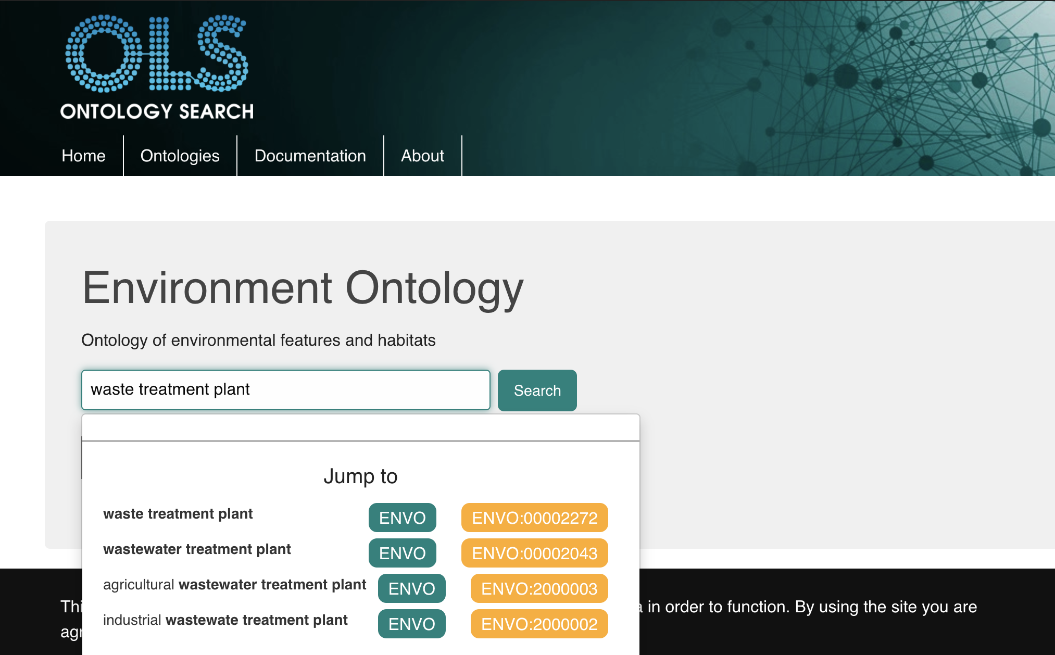

Many search results are returned, but we can see a term “waste treatment plant” that matches our term. Copy the term and paste it into your collection template under the “environmental location” column.

For more information and/or assistance, contact datastructures@pha4ge.org.

**Revision History**

|  |  |  |  |
| --- | --- | --- | --- |
| **Version** | **Date** | **Writer** | **Description of Change** |
| 0.0 | May 25, 2020 | Emma Griffiths | Created protocol |
| 1.0 | June 23, 2020 | Emma Griffiths | Protocol edited |
|  |  |  |  |
|  |  |  |  |